Follow along with the "Fix Cors in Firefox" video:
1. Take a screenshot of your browser showing the page not loading properly in the beginning.
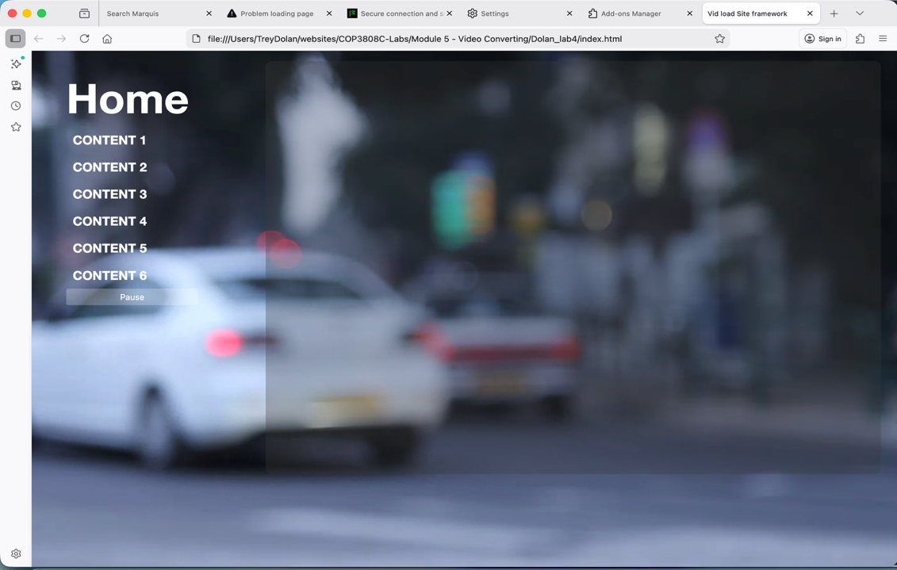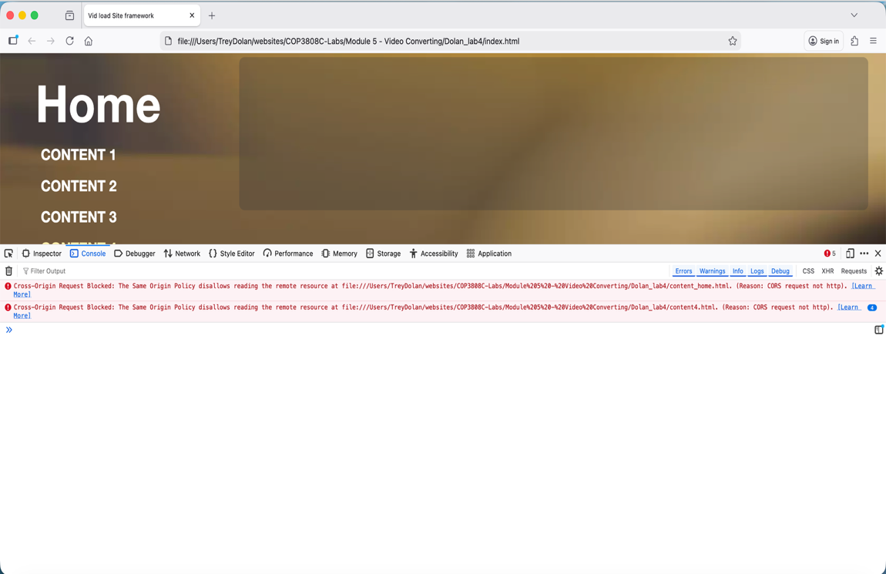
2. Type about:config in the address bar. Accept the risk (but only follow along, don’t change other things). Search for origin. Find the file called security.fileuri.strict_origin_policy. Change it to false by double clicking on true. Take a screenshot showing it changed to true and then restart the browser.
Place the screenshot here.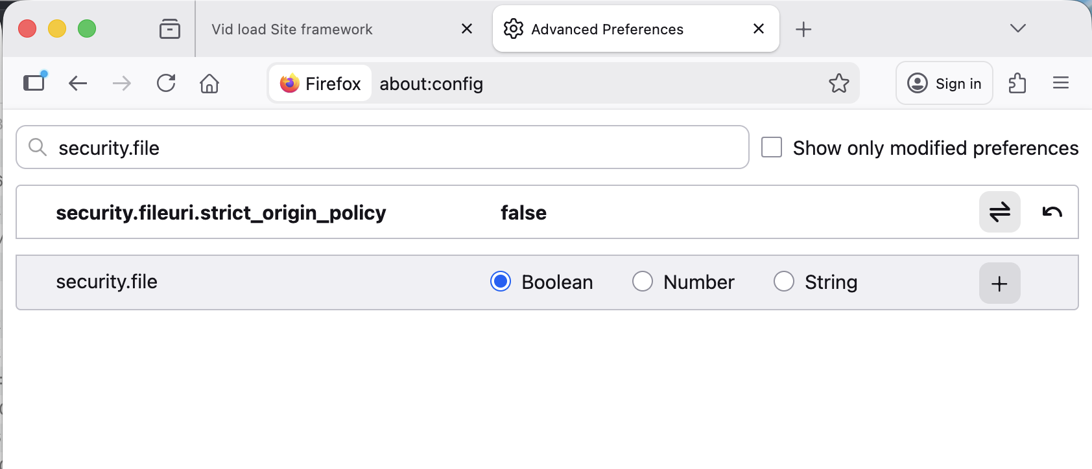
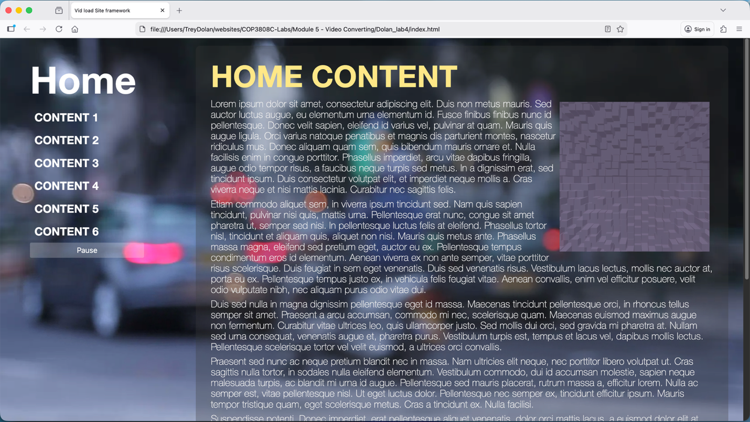
Additional information about fixing Cross Origin Request Security (CORS) errors in other browsers:
https://developer.mozilla.org/en-US/docs/Web/HTTP/Guides/CORS/Errors
https://www.webdavsystem.com/ajax/programming/cross_origin_requests
Next, refer back to the "Video Backgrounds" video and follow along:
1. Go to the website www.coverr.co.
2. Browse the categories and choose nature. Roll over a few and play a few of them. (Do not choose Shutterstock. Those are not free).
3. Find one you like and download it. You can skip signing up for anything.
4. Locate the mp4 in your classwork folder (you may also get a static image). Take a screenshot of the file downloaded and saved it to your classwork folder.
Place the screenshot here.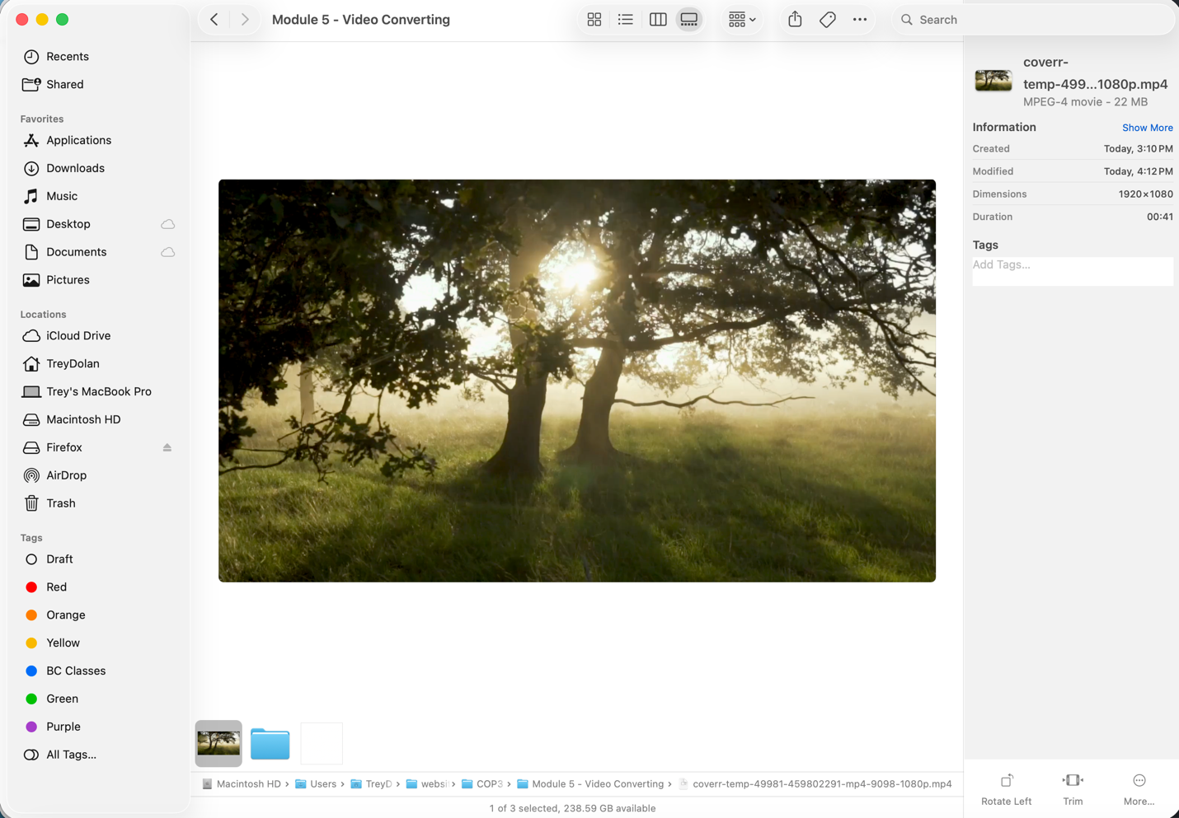
5. Go to video.online-convert.com (or any site you prefer to conver the mp4 to webM).
6. Convert the mp4 to webM just using defaults. Take a screenshot of the video being converted.
Place the screenshot here.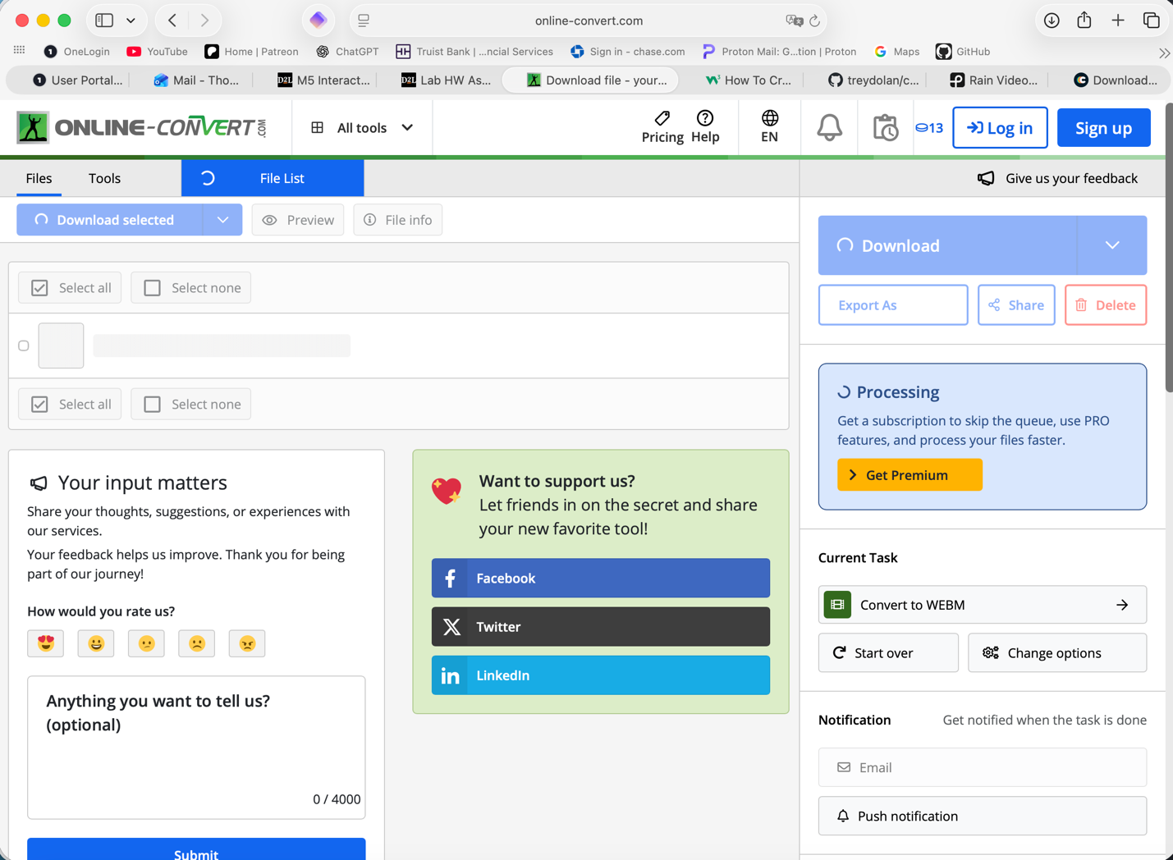
7. Download the new webM video to your classwork folder. Re-name them with shorter names and take a screenshot of both video files together and their file sizes:
Place the screenshot here.